Irrigation webinar series
Webinar 2: Where is the water market heading in the long-term?

This webinar will provide estimates of future southern Murray-Darling Basin water allocation prices based on expert insights and detailed modelling of the key drivers of the water market. Information will be presented to assist irrigators to better prepare their farm businesses for the future.

Topics

Key drivers of the water market and future scenarios will be discussed, including:
- Climate change and its impact on irrigation water availability
- Changing land and water use in the connected Basin, including horticultural expansion
- The Commonwealth water buyback
- Inter-Valley Trade Limits

EXPERT Speakers

Chris Olszak Erin Smith

Founding Director Principal Consultant

Aither Aither

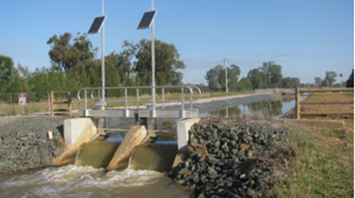

when
Thursday 28 January 2021, 1-2 pm.
HOW TO REGISTER
To register in advance for this webinar go to bit.ly/AgVicWMW2 After registering, you will receive a confirmation email containing important information about joining the webinar. For technical issues, please call John Paulet on 0429 158 500. For information on the webinar series, call Rob O’Connor on 0408 515 652.
REPORT FINDINGS
Aither has recently produced a detailed report "Southern Murray-Darling Basin Water Market - Recent and Future Trends and Drivers", for the Department of Environment, Land, Water and Planning. Some findings from this report will be discussed in the webinar.
MORE IRRIGATION WEBINARS TO COME
Webinars will be held monthly from January onwards. The initial focus of the webinar series is on water trade. The next webinar will be held in late February on the topic of understanding and managing water price variability on farm.

